1 => In admin, when I open a branch I would like to see a branch name and ID printed on the page

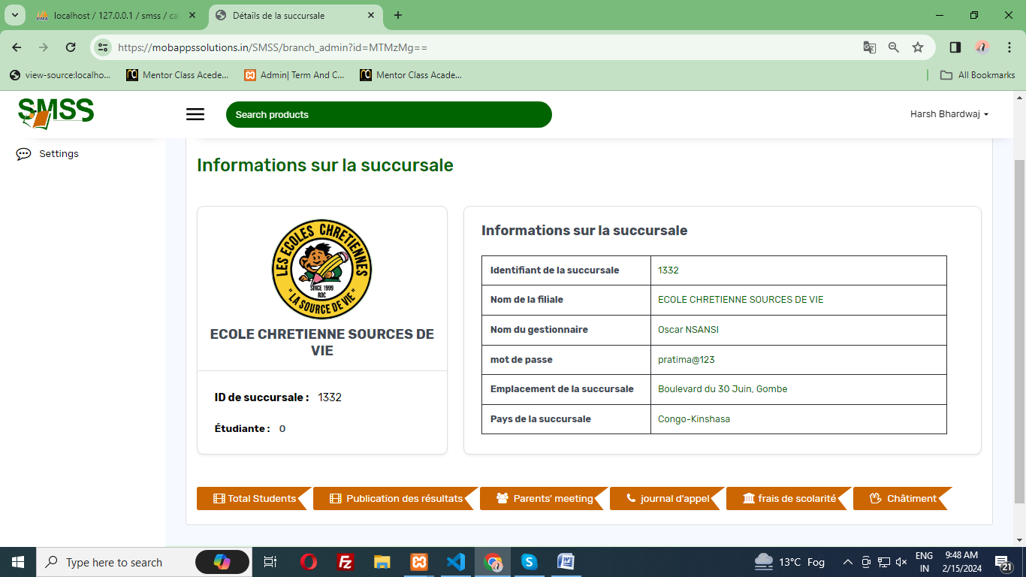

=> Here you can see the branch name and branch id -> Done

- you need to allow us to type student information when they paid school fees
- like id ked, name, a mound paid, balence, total maybe to have receipt on the end

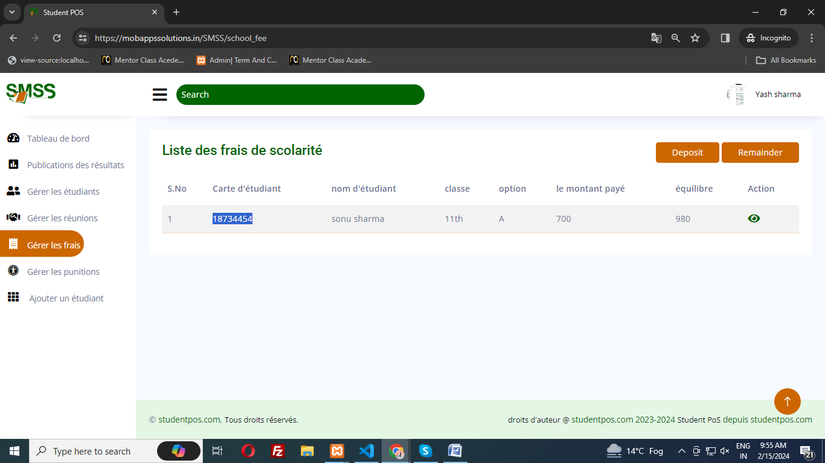

- This page allow to branch admin submit the fee for particular student. When you click on deposit button the you can see the popup where you can deposit the school fee. -> Done
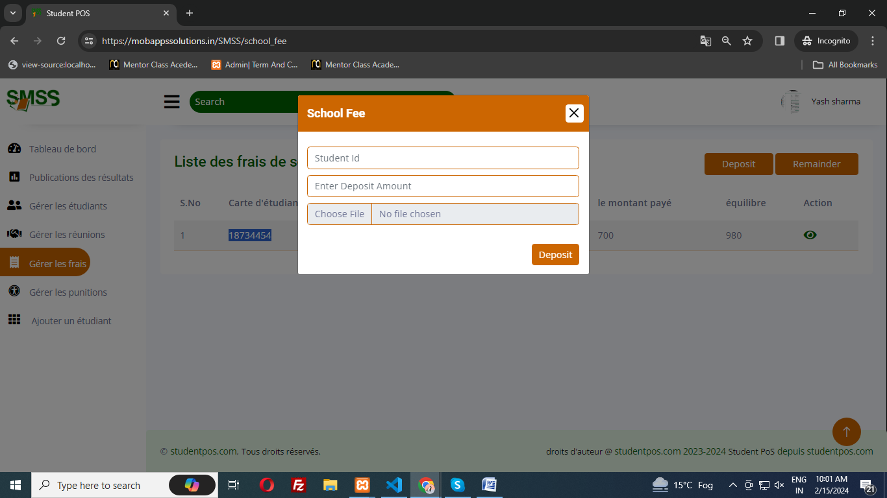
- Here when you entered the student id. You can see the All Details. like id ked, name, a mound paid, balance, total amount. Please see below -> Done
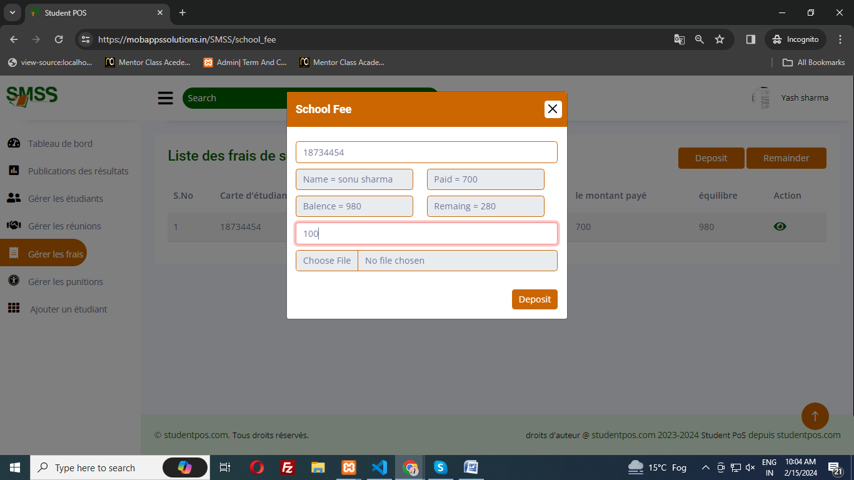

- Here You can see the all student school fee when you click the see button you can see how many installments amount paid -> Done



Please see below

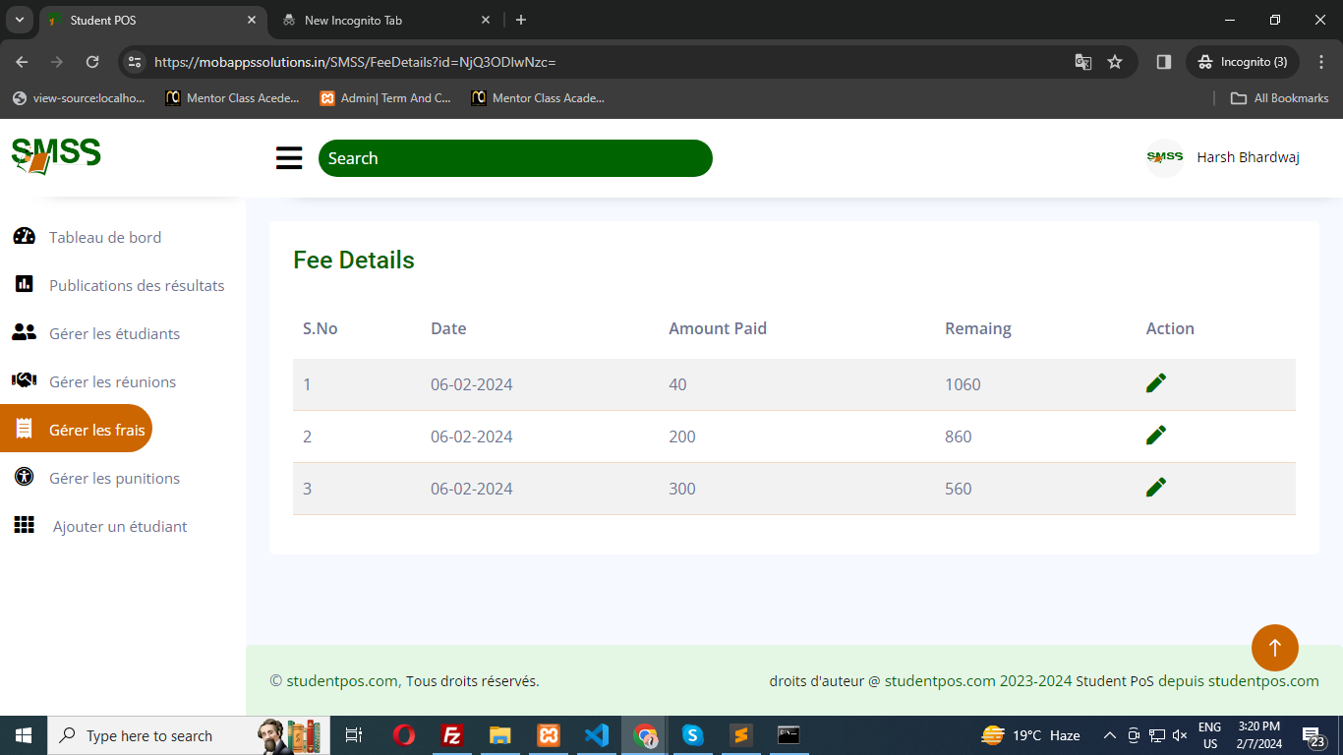

You can also edit the amount here. -> Done

- when I clic, I can see list class and effectif student

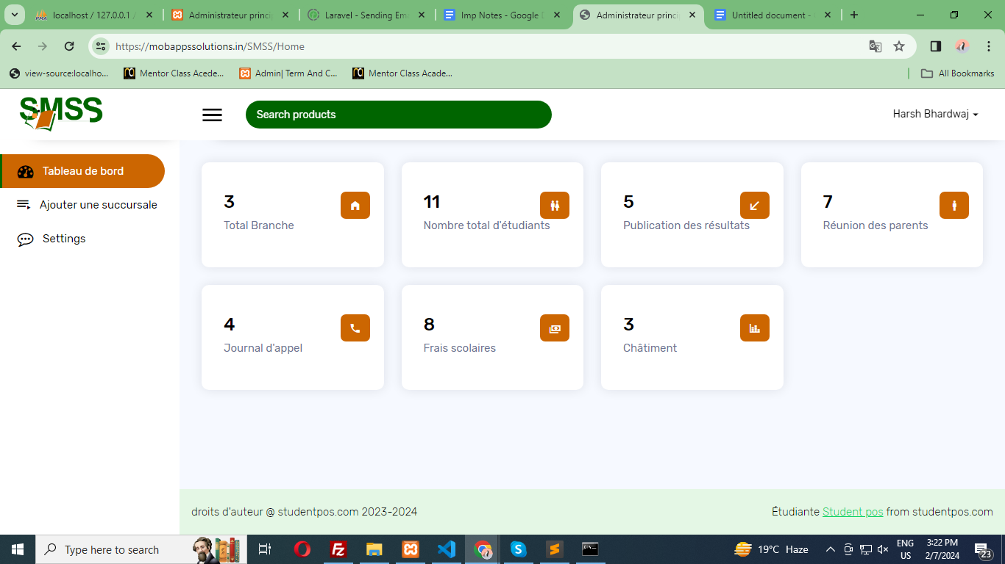

When you click “Nombre total d'étudiants” You can see all student basis of class and option -> Done

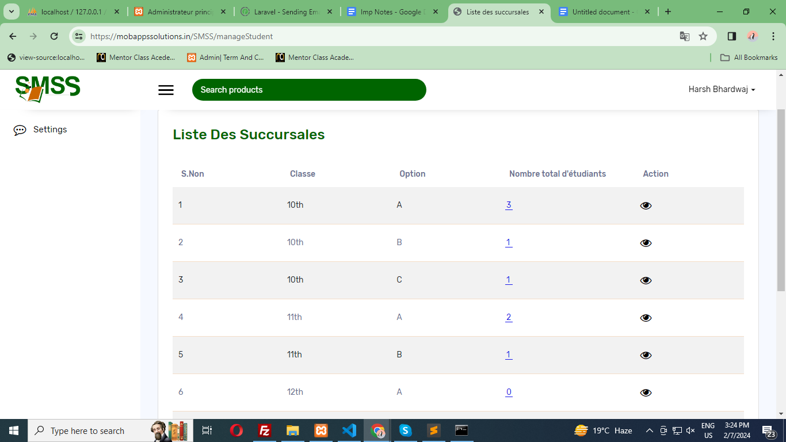

When you click see button you can see how many student in particular class and option. -> Done

- student List there is not phone number
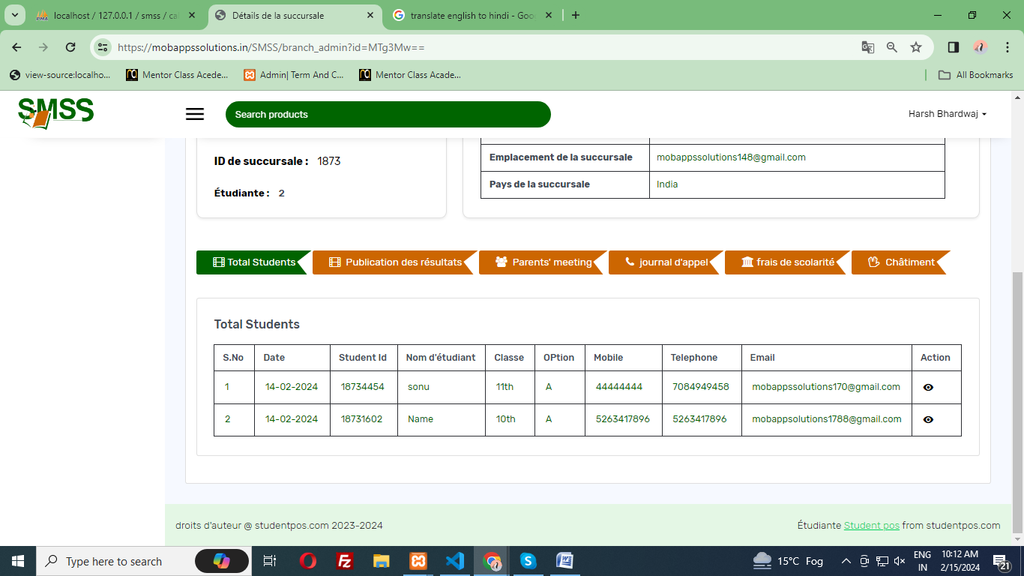

- Look put this fied Prénom, Nom, Post-Nom, Telephone, Mobile, Email, ID



- List resultat needs to be splited by branch and class

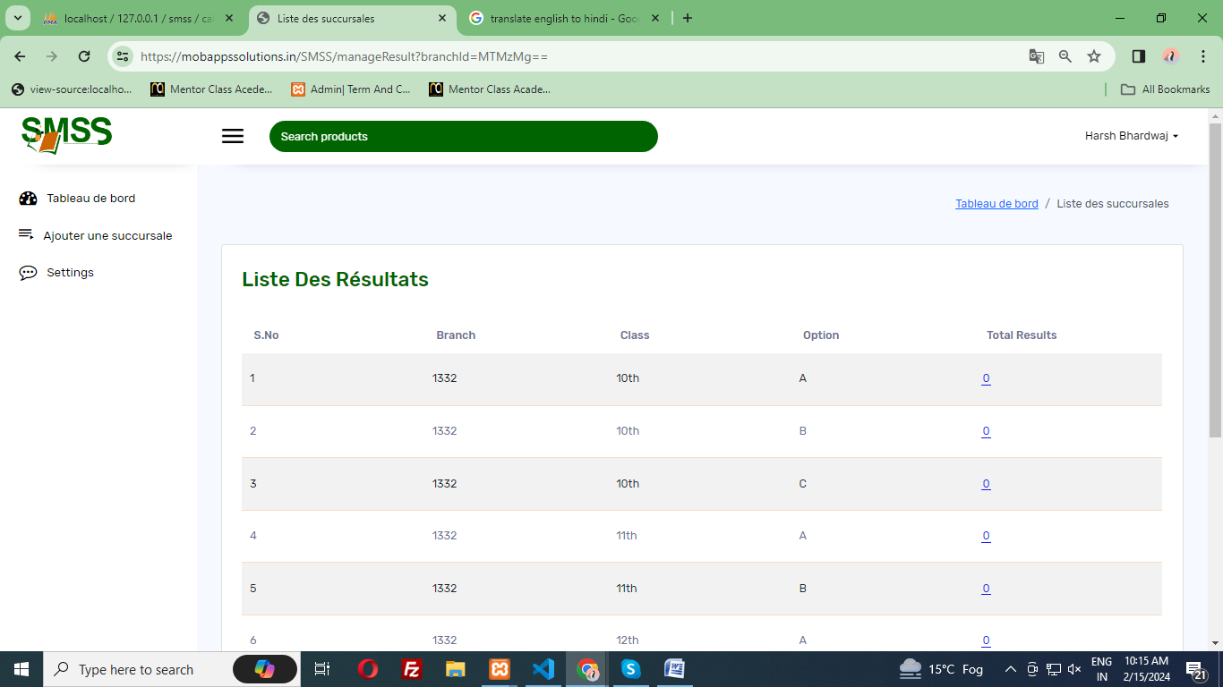

When you click “Publication des résultats” you can see All result for class and option -> Done

When click you total result you can see result or particular class and option. -> Done

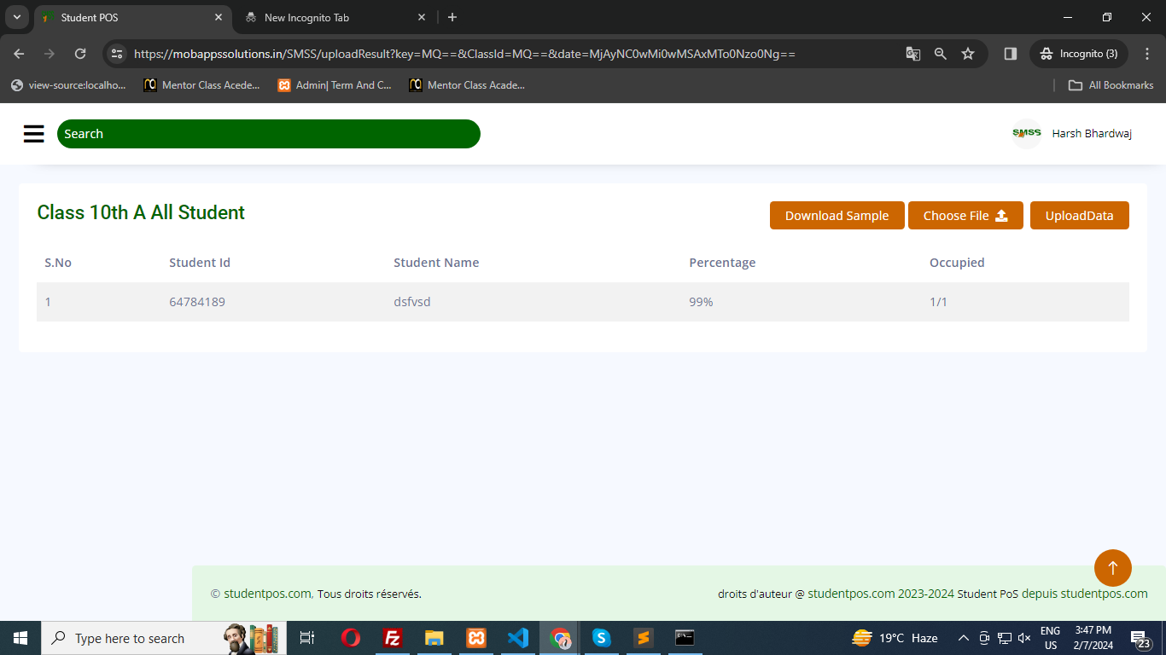

- reset school fee, where can I do it

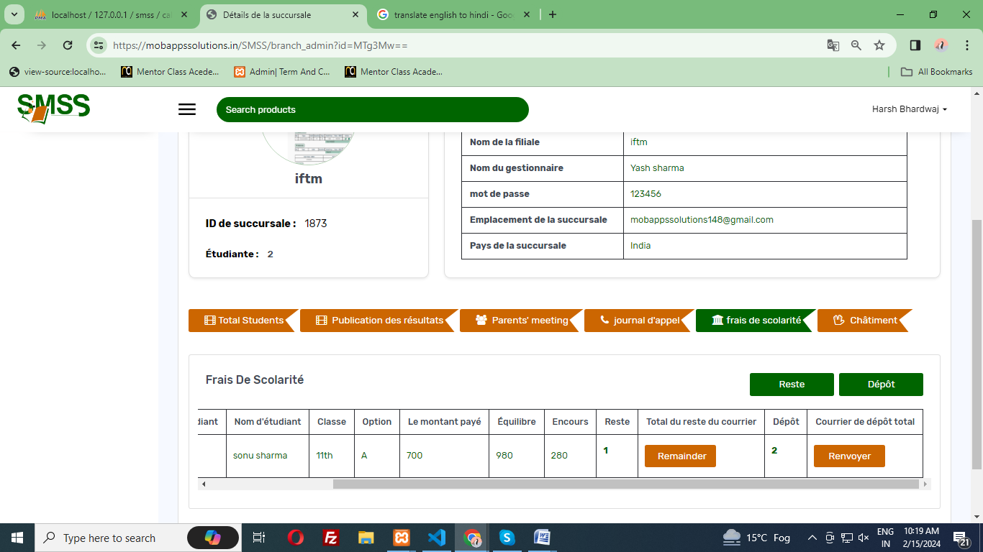

- Here You can reset the school fee from admin section. These are two button for remainder(remainder) and Renvoyer(Deposit) -> Done

- where admin can register and update email or sms notification dear.

- Successfully done when admin register the branch then branch have receive the mail and when the admin update the branch then branch received the mail. -> Done

- And when the branch register the student then student receive a mail for registration successfully -> Done

- notification needs to be send on time, you pay you receive

- Done Please check -> Done

- and other possibility to send on bulk

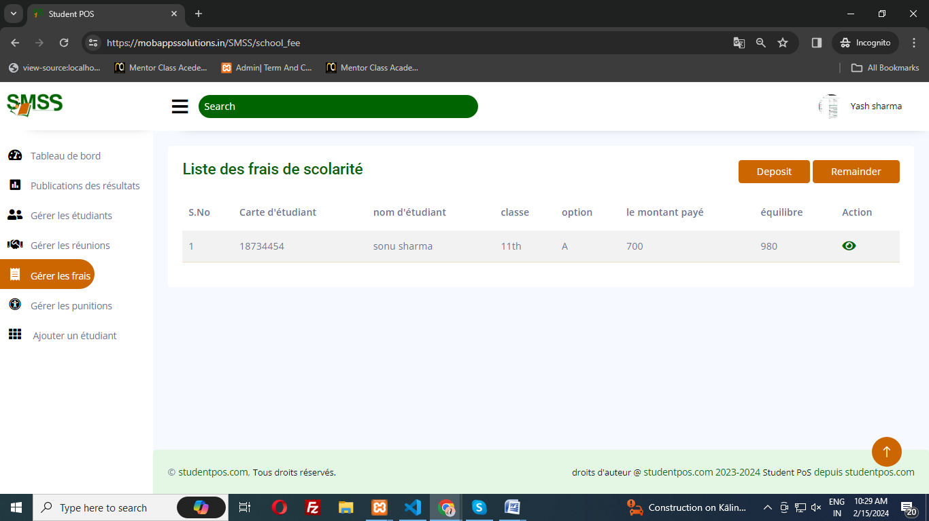

Here you can send the bulk remainder message for all student -> Done

